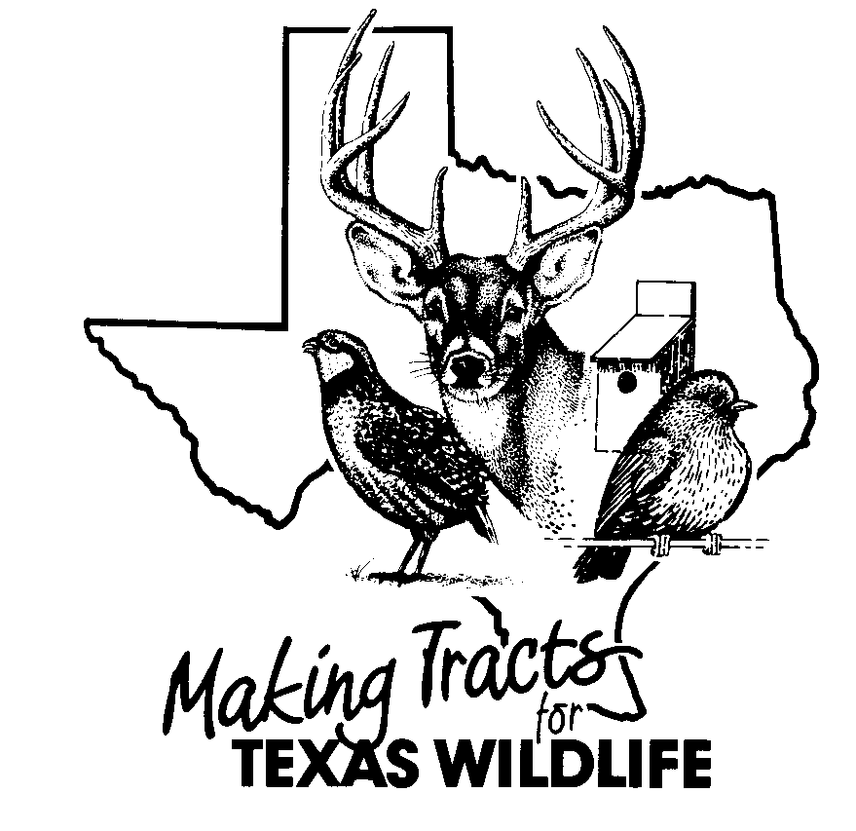


LANDOWNER REQUEST FOR TECHNICAL GUIDANCE

CONCERNING DEVELOPMENT PROJECTS

(check all that apply)

□ I hereby request technical guidance from the Texas Parks and Wildlife Department (TPWD), Wildlife Division field staff, regarding the evaluation of the potential impacts a proposed development project, such as an electric transmission line, pipeline, roadway or other project (project), may have on my efforts to conserve and enhance wildlife habitat and manage wildlife resources on my land.

□ I understand that TPWD does not represent or advocate for private parties (such as landowners, and developers) in connection with a project. I understand that under Parks and Wildlife Code Section 12.0011, TPWD may make recommendations to governmental bodies to protect wildlife resources in the State of Texas.

□ I hereby grant permission to the TPWD, Wildlife Division field staff, to enter upon my land and conduct, at a mutually agreeable time, wildlife and habitat inventories which may include the use of ground vehicles, aircraft, or nighttime spotlight counts to gather data necessary for the evaluation of potential impacts of the project(s) and formulation of management recommendations in connection with the proposed project(s) on my land.

□ I understand that under Section 12.0251 of the Parks and Wildlife Code, information collected by TPWD on private lands in response to a landowner request relating to the specific locations, species identification, or quantity of animal or plant life is confidential and may not be disclosed by TPWD without my written consent.

□ I hereby authorize TPWD to release any information collected by TPWD on my land in response to this request for technical guidance concerning a project to the governmental body charged with approving, permitting, licensing, or constructing the proposed project(s) on my land. I understand that if this information is released to the governmental body, the information may be considered public information under the Texas Public Information Act (Government Code, Chapter 552).

□ I understand that TPWD may draft a comment letter to me regarding the potential impacts of the project on my efforts to conserve and enhance wildlife habitat and manage wildlife resources on my land (comment letter). I may provide the comment letter to the governmental body charged with approving, permitting, licensing, or constructing the proposed project(s) on my land. I may also authorize TPWD to provide a copy of the comment letter to the governmental body charged with approving, permitting, licensing, or constructing the proposed project(s) on my land.

□ I hereby authorize TPWD to provide a copy of the comment letter to the governmental body charged with approving, permitting, licensing, or constructing the proposed project(s) on my land.

Signed:___________________________________________________________________
Landowner Date

Name of Property:__________________________________________________________

County:________________________________Acres:______________________________

City, State, Zip:_____________________________________________________________

Home Phone:_______________Office Phone:________________Other:_______________

E-mail address:_____________________________________________________________

Mailing Address:____________________________________________________________

Title V Compliance: The Texas Parks and Wildlife Department provides this service to land managers without discrimination in
respect to race, color, national origin, age or handicap. Texas Parks and Wildlife Department maintains the information collected through this form. With few exceptions, you are entitled to be informed about the information we collect. Under Sections 552.021 and 553.023 of the Texas Government Code, you are also entitled to receive and review the information. Under Section 559.004, you are also entitled to have this information corrected. For assistance call 512-389-4959. PWD 1259-W7000 (7/09)

